Assignment 3

Step 1:
First, the sign up page comes when the app is opened. In this page, personal details like First name, Last name , Address and password for the login are given. We can take the picture by using the Image tab.

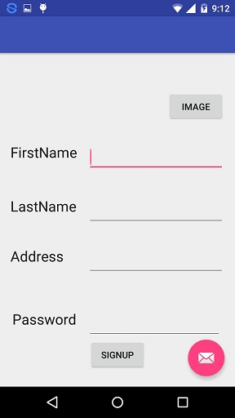

Step 2:
You can enter all the details like First name,Last name and Address etc.

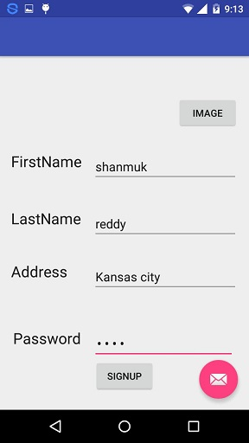

Step 3:
When you press signup button, you will be redirected to your current location where the picture taken is populated near the current location.

